# **CSE250 [Review]**

### **1. Draw the alternate representations of the following circuits** *[Note that the number of floating sources should be minimized]***.**

1. 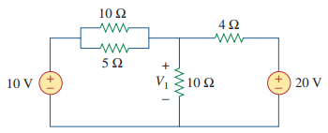
2. 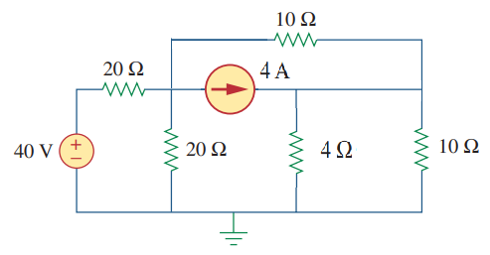

### 2. Find the loop representation of the following circuit:

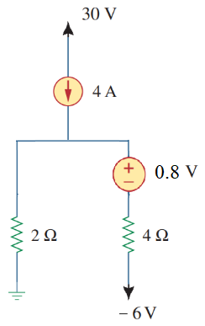

### 3. Here, vx = (10+last digit of your ID) V

### 

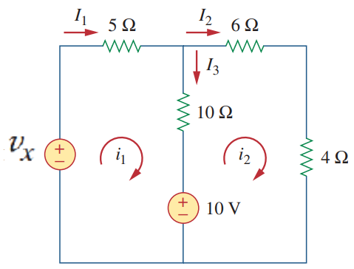

**(i) Draw the alternate circuit representation** of the circuit shown in the Figure above*[Note that the number of floating sources should be minimized]***.**

**(ii) Apply KCL and KVL** on the circuit drawn in (i) and **calculate I1, I2, and I3.**

### 4.

| **In the above circuit $A=100$, $R_{i}=100 kΩ$ and $R_{o}=1 kΩ$. Answer the following questions** | | |
| --- | --- | --- |
| 1. Write the node equations for the nodes indicated by $v_{i}$ and . | [CO1] | 4 |
| 1. Solve the node equations to find the values of $v_{i}$ and **.** | [CO2] | 3 |
| 1. Can circuit theorems based on linearity principle (such as superposition principle) be applied to the above circuit? Explain in short why or why not. | [CO1] | 3 |

## 

# **Op-Amp**

### Observe the following circuit.

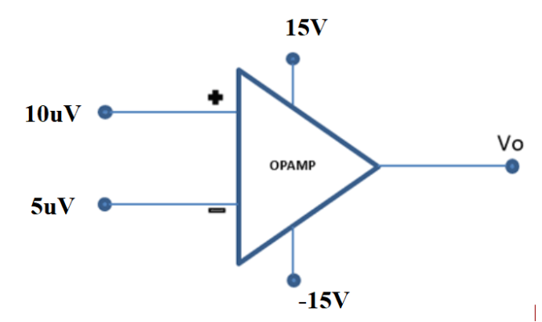

Calculate the value of Vo. Repeat the problem with V+=1 mV and V-=0.2 mV. Consider A=2105.

### Draw output Vo for the following op-amp circuit.

### 

VCC = 15V= -VEE , Vref = 1.5V, Vi is a 6V p-p triangular signal as shown below.

### 

### 

### Design a circuit using **op-amp** that has the voltage transfer characteristics as shown in the figure below. $v_{O}(V)$ is the **output voltage** and $v_{I}(V)$ is the **input voltage**.

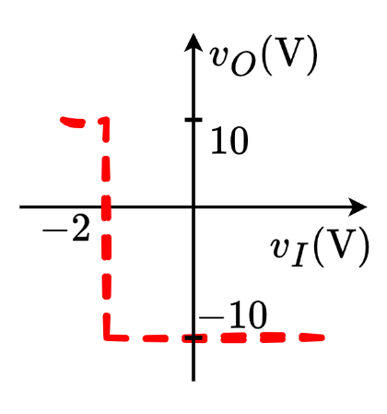

### 5.

A valve is used to release (when valve is OPEN,) or maintain (when valve is CLOSED,) water pressure in a water tank. The valve operates on **ACTIVE LOW** logic. (i.e., the valve is OPENED when given a LOW voltage of $1 V$**,** but remains CLOSED when provided a HIGH voltage of $6 V$**.**)

A pressure sensor is installed in the water tank that outputs a voltage linearly proportional to pressure, as shown in the table below.

| At **0.5 atm** pressure | At **1 atm** pressure | At **1.5 atm** pressure |
| --- | --- | --- |
| $v_{ 0.5 atm}=0.5 V$ | $v_{1 atm}=3 V$ | $v_{ 1.5 atm}=5.5 V$ |

The pressure in the water tank can be measured by the formula $P=hρg$, where $P$**,** (in **Pascals (Pa)** unit) is the water pressure, $h$ is the height of water in the tank (in $metres$), $ρ(=1000 kgm^{-3})$ is the density of water and $g$ is the acceleration due to gravity (in $ms^{-2}$).

**[1 atm = 101325 Pa]**

1. **Design** a circuit using Op-Amp comparator to automatically turn OPEN the valve if water level exceeds **10 m**.
2. **Draw** the voltage transfer characteristics (VTC) of the designed Op-Amp.

### 6.

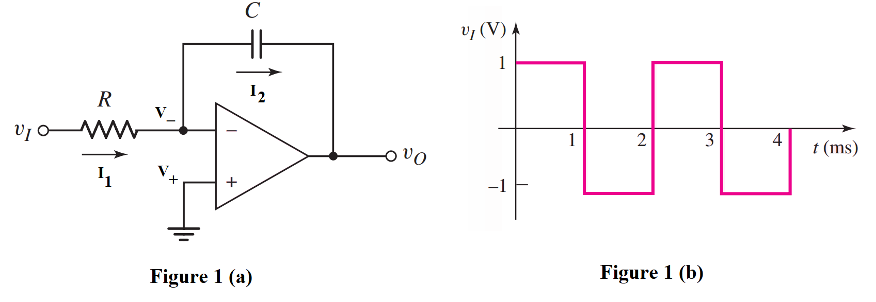

1. **Analyze** the circuit drawn in Fig. 1(a) and **determine** the voltage values at the inverting and non-inverting nodes (V- and V+). [0.5+0.5]
2. **Identify** the relation between I1 and I2. [1]
3. **Analyze** the circuit to derive the expression of output voltage vo. You have to **show** all the steps. [3]
4. Now consider the input wave v1 given in Fig. 1(b). For circuit parameters R = 10 kΩ and C = 0.1μF, **determine** the output voltage at t = 1 ms. [1]
5. **Design** a circuit using Op-Amps to implement the following expression: [4]

$f=\frac{1}{4}x+7y-\frac{d}{dt}z$

### 7.

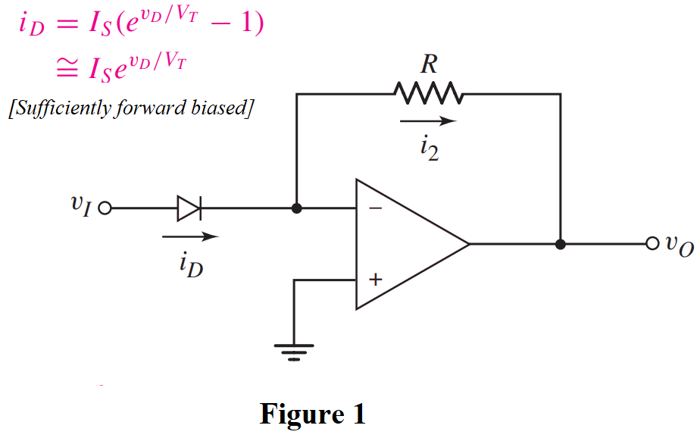

1. **Analyze** the circuit drawn in Fig. 1 and **determine** the voltage values at the inverting and non-inverting nodes (V- and V+). [0.5+0.5]
2. **Identify** and briefly explain the relation between i2 and iD. [1.5]
3. **Analyze** the circuit to derive the expression of output voltage vo. You have to **show** all the steps. [3.5]
4. **Design** a circuit using Op-Amps to implement the following expression: [4]

### 8.

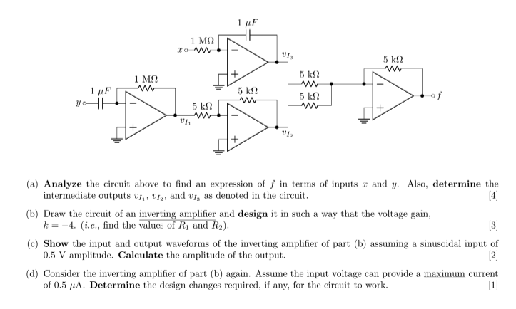

### 9.

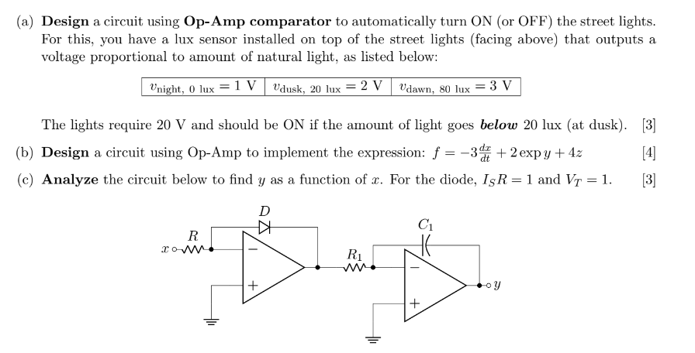

### 10. **Deduce** the expression for output, **Vo** from the circuit above

### 11. Design a circuit using op-amps to implement y=7x by an

1. Inverting amplifier
2. Non-inverting amplifier

### 12.

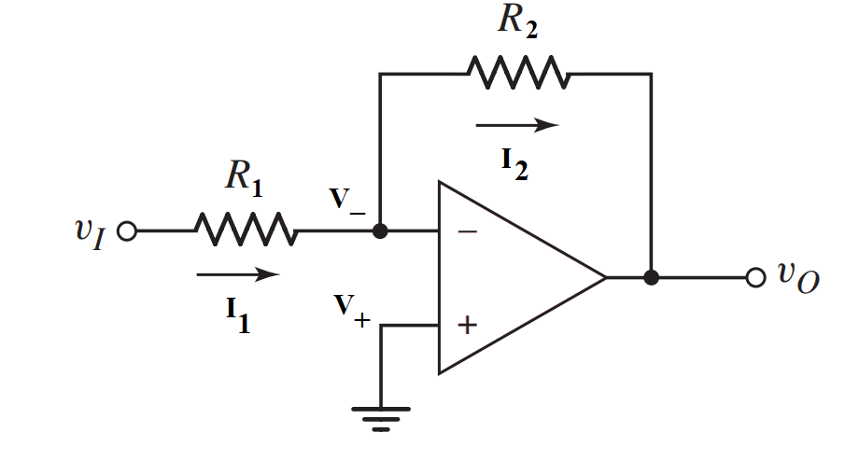

1. **Design** an inverting amplifier (i.e., find the values of R1 and R2 of the circuit shown in the Figure above) in such a way that the voltage gain is **−5**.
2. Consider the circuit you drew in (a) again. Assume the input vi = 0.1 sinωt (V) has a maximum current rating of 5 μA. What design changes, if any, are required for this input, if the voltage gain remains the same?
3. **Draw** the input and output waveforms of the circuit you designed in (c).

* **Analyze** the following circuit and derive the expression for the output voltage (Vout) in terms of the inputs. If V1=1 V, V2 = 2V, and V3 = 1.5 V, and all the resistors have equal values, calculate Vout.

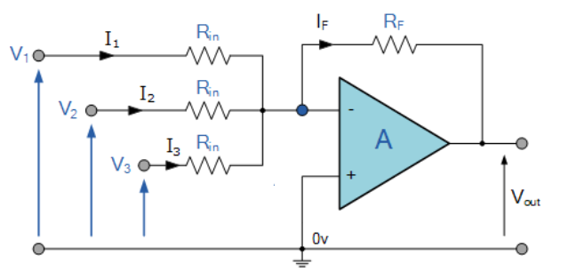

### 13. **Analyze** the following circuit to find an expression of f in terms of x, y, and z.

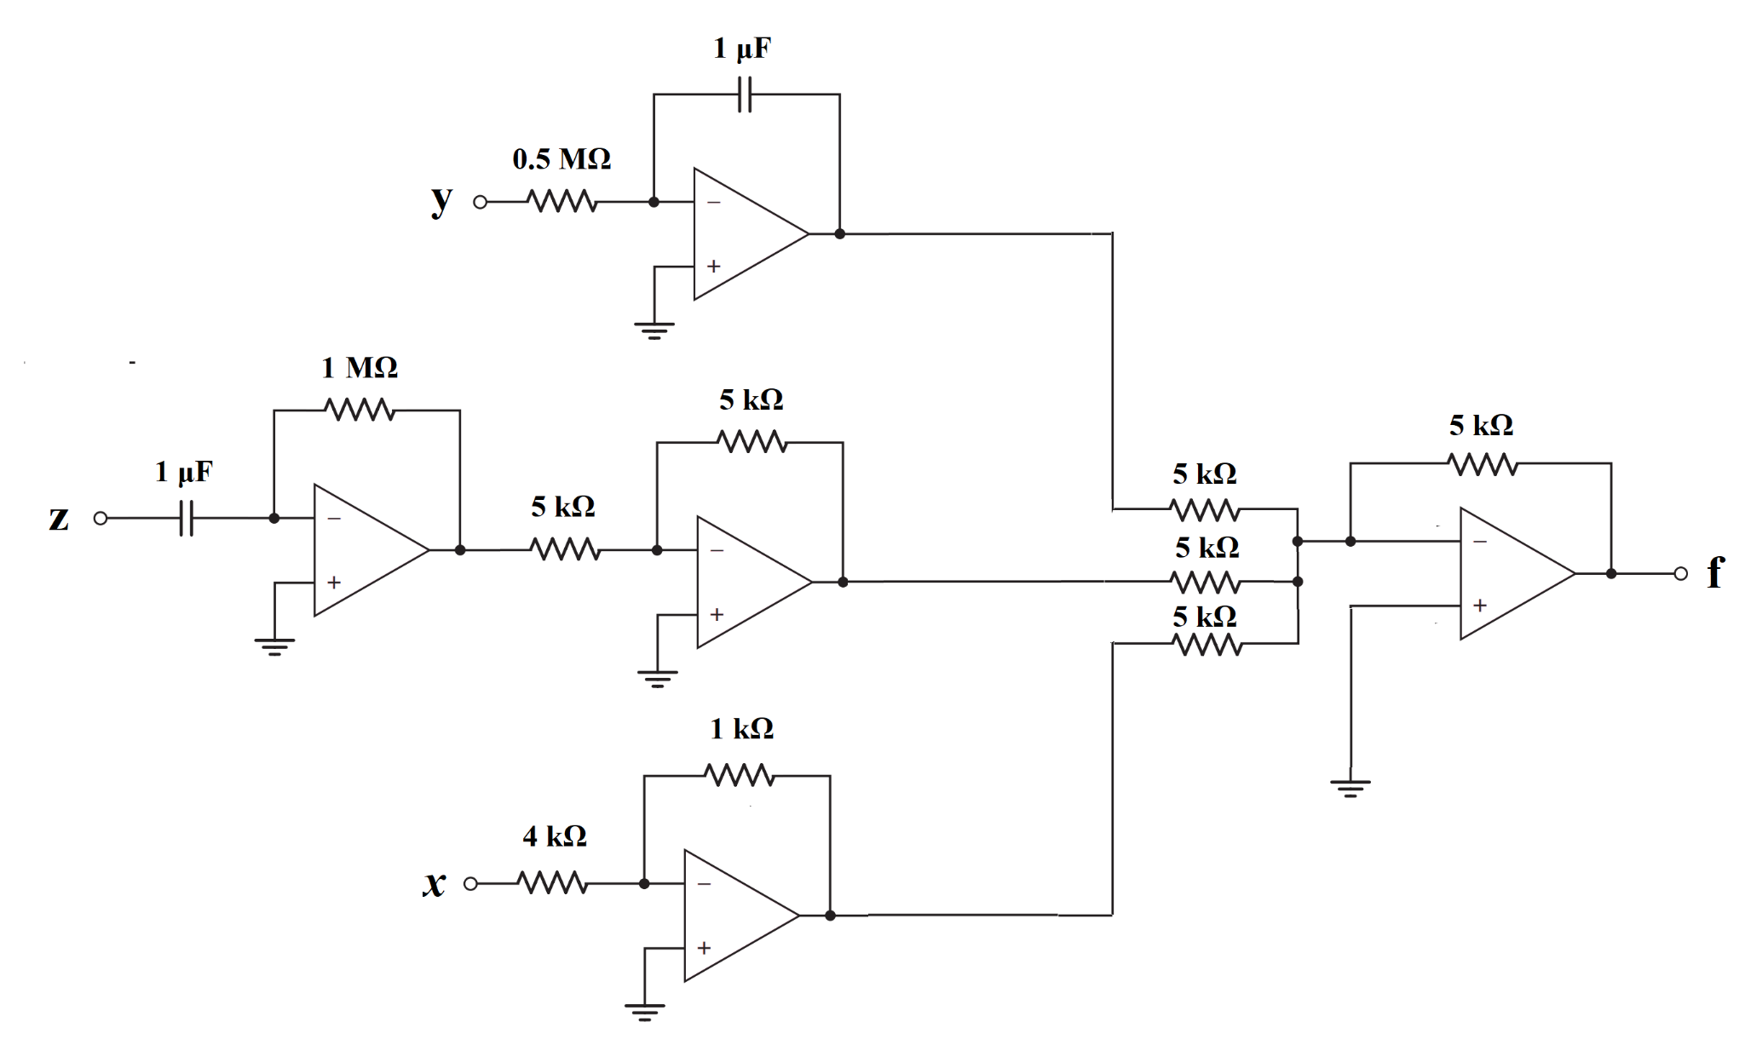

### 14. Consider the Ideal Op-Amp and find the value of Vo.

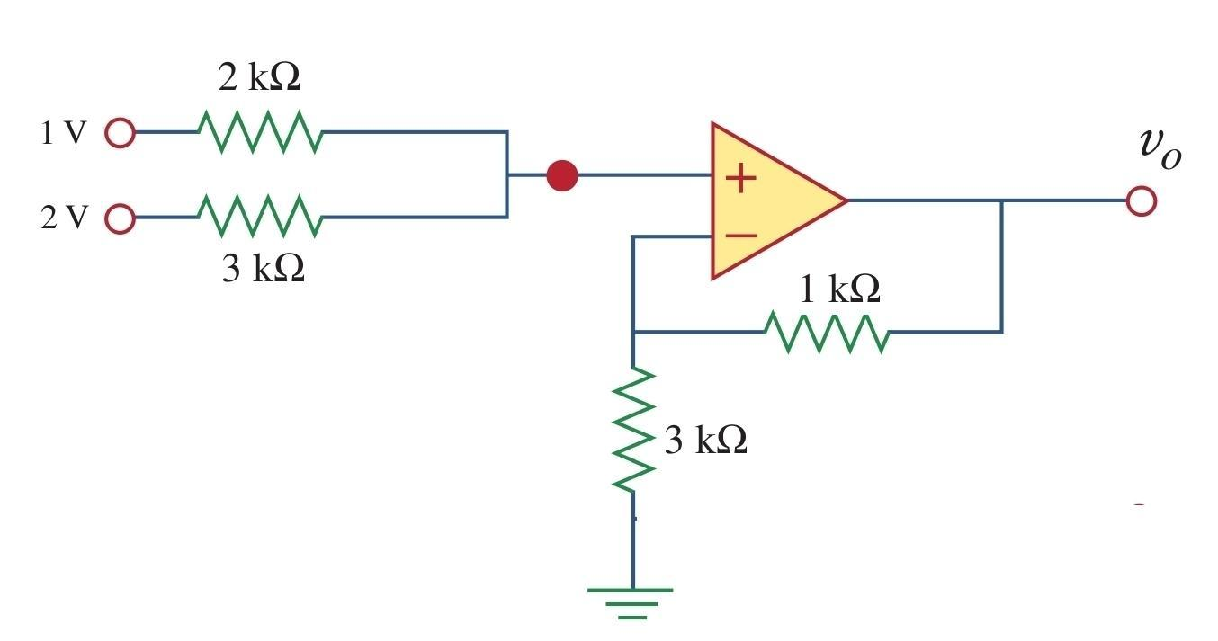

### 15.

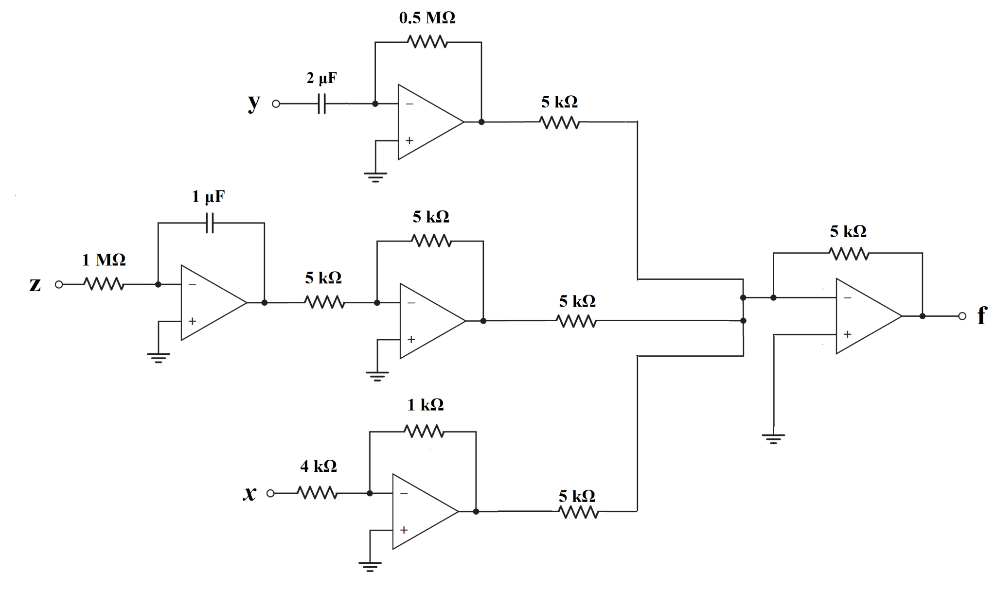

**Figure 3(a) Figure 3(b)**

1. **Analyze** the circuit in Fig 3(a) to find an expression of f in terms of x, y, and z. [4]
2. **Design** an inverting amplifier (i.e., find the values of R1 and R2 of the circuit shown in Fig. 3(b)) in such a way that the voltage gain is **−4**.  [3]
3. **Draw** the input and output waveforms of the circuit you designed in (b). [2]
4. Consider the circuit in Figure 3(b) again. Assume the inpurt vi = 0.1 sinωt (V) has a maximum current rating of 4 μA. What design changes, if any, is required for this input, if the voltage gain remains the same?

### 16.

**Design** an op-amp circuit to transform the sinusoidal voltage, $v_{I}=5⋅sin⁡(\frac{2π}{5}⋅t)$ ( $- t$ is in units of $ms$**,** and time-period $T$ is $5 ms$), to: 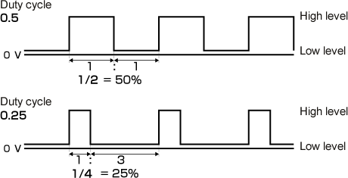

**[You must evaluate $V_{REF}$]**

1. A square wave with a duty cycle of **50%**.
2. A square wave with a duty cycle of **25%**.

[**Duty Cycle:** Time of positive half cycle $÷$ Time period]

For more information on duty cycle, click [here!](https://www.youtube.com/watch?v=u9M9REUmmDI)

[**Hint:** If $y=\left(θ\right)$ is a sinusoidal function with period of $2π$ then $θ=(\frac{y}{A}) and π-(\frac{y}{A})$. So, for 25% duty cycle find the value of $y$ for which $Δθ=\left(π-(\frac{y}{A}) \right)-\left(\frac{y}{A}\right) =\frac{Time period}{4}=\frac{π}{2}$]

### 17. Miscellaneous

**Determine the output voltage, $v_{0}$**

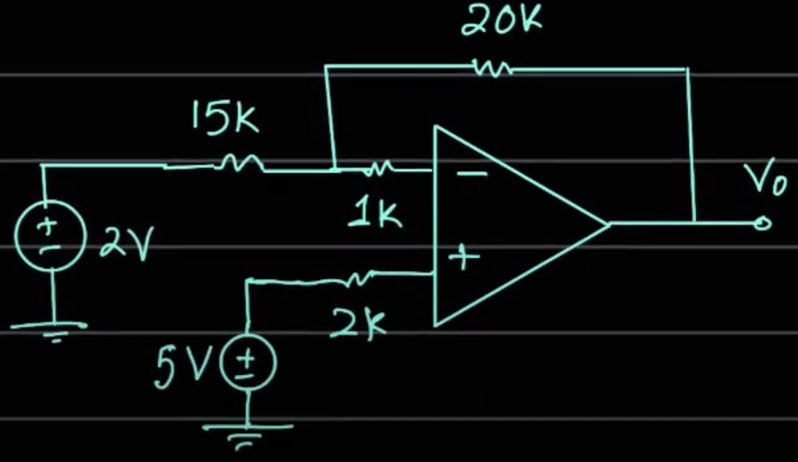

### 18. Miscellaneous

**Determine the output voltage, $v_{0}$**

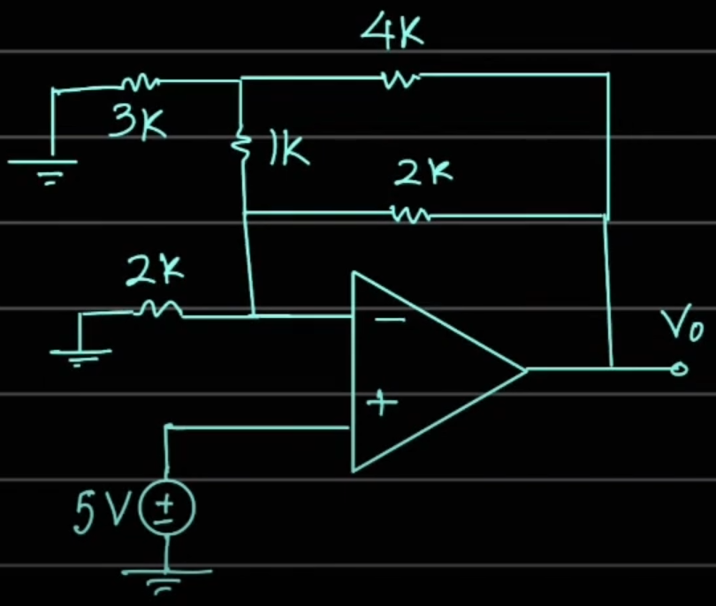

### 19. Miscellaneous

**Determine the voltages: $V_{01}$, $V_{X}$, $V_{02}$**

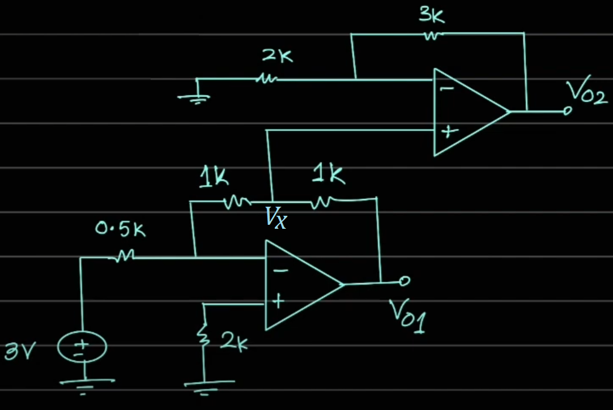

### 20. Miscellaneous

**Determine the marked currents and the output voltage** 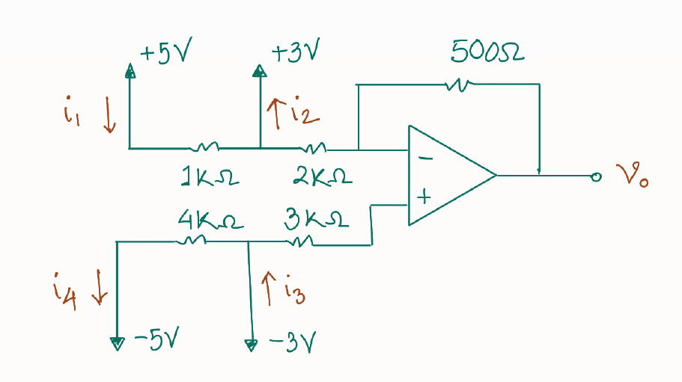

### 21. Miscellaneous

**Determine the appropriate value of $R_{1}$**

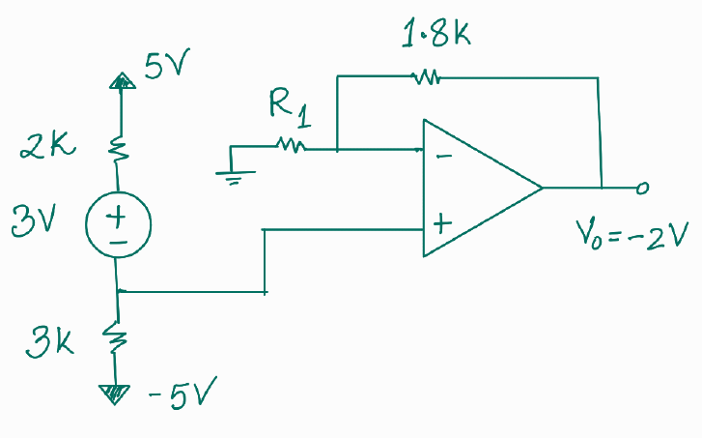

### 22. Miscellaneous

**Express the output voltage $v_{0}$ in terms of all the other quantities shown in the circuit below.**

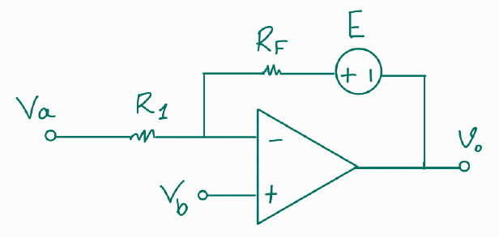

### 23. Miscellaneous

**Determine the output of the comparator, $V_{0}$ after finding $V_{a}$ and $V_{b}$.**

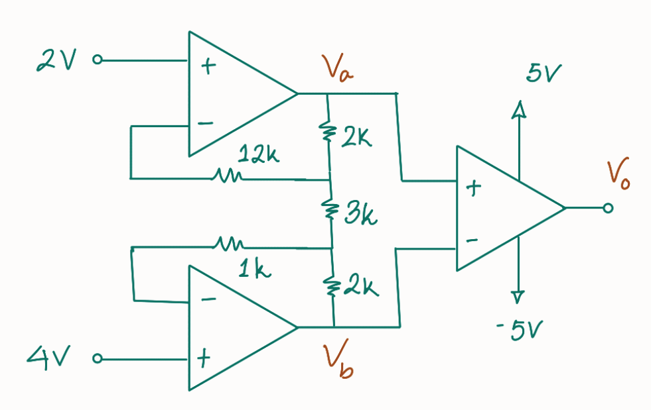

### 24. Miscellaneous

**Draw the correct waveform of ${ V}_{0}$ (with voltage labels) alongside the input waveform of $E$.**

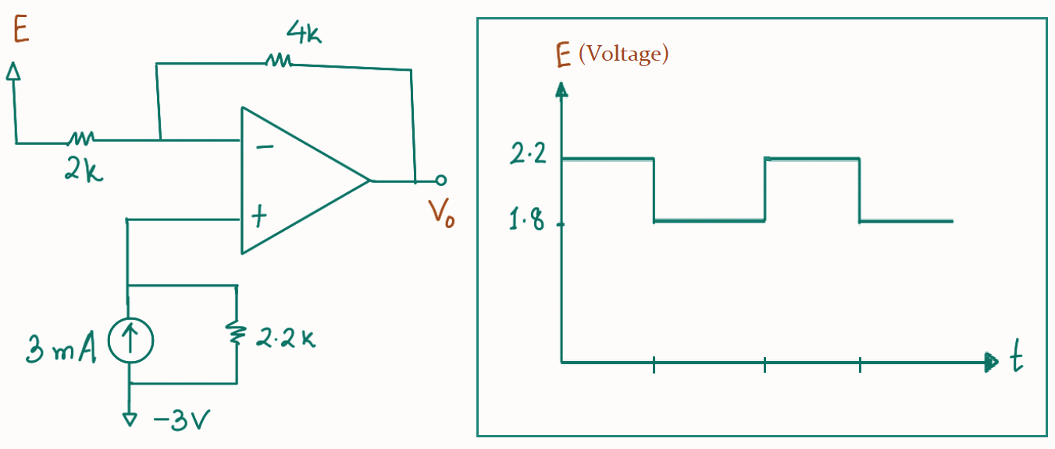

### 25. Miscellaneous

**We know that the input-output relationship of an ideal inverting amplifier with op-amp is given by:**

${ V}_{0}=$ $-\frac{R_{F }}{R_{1}}{ V}_{in}$

**However, realistic op-amps are non-ideal. Determine the input-output relationship of a non-ideal inverting amplifier. Use the equivalent circuit of an op-amp which contains ${ A , R}_{i} ,R_{0}.$**

### 26. Miscellaneous

**Draw the approximate waveforms of both ${ V}_{A}$ and ${ v}_{0}$ from the circuit below.**

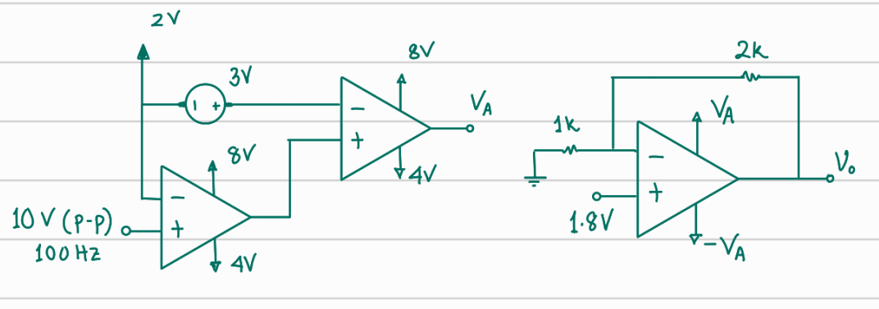



### 27. Miscellaneous

**After drawing both $z(t)$ and $h(t)$, determine the relation between them.**

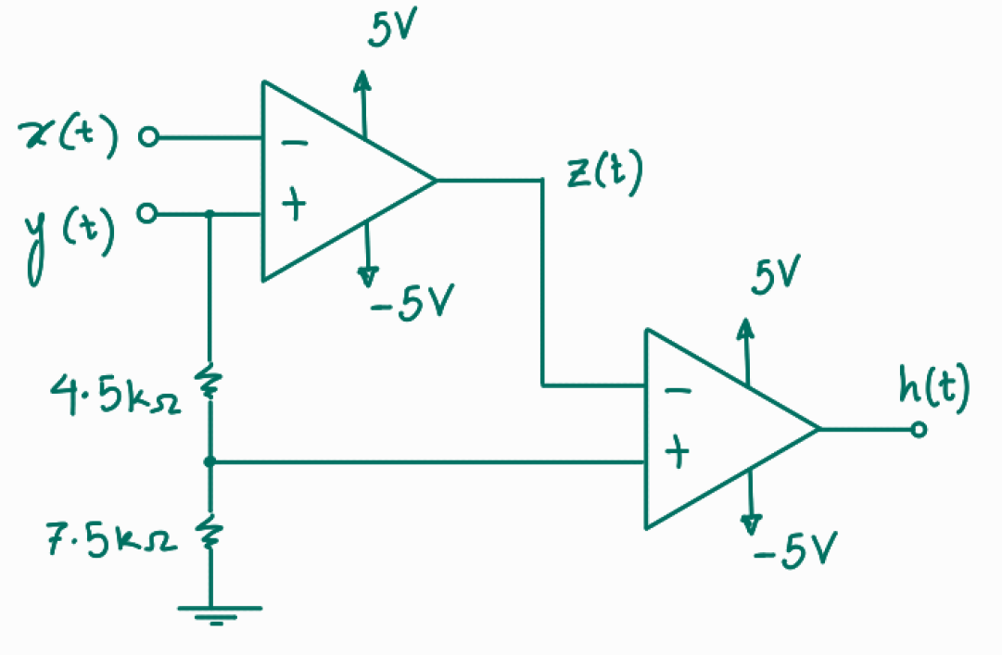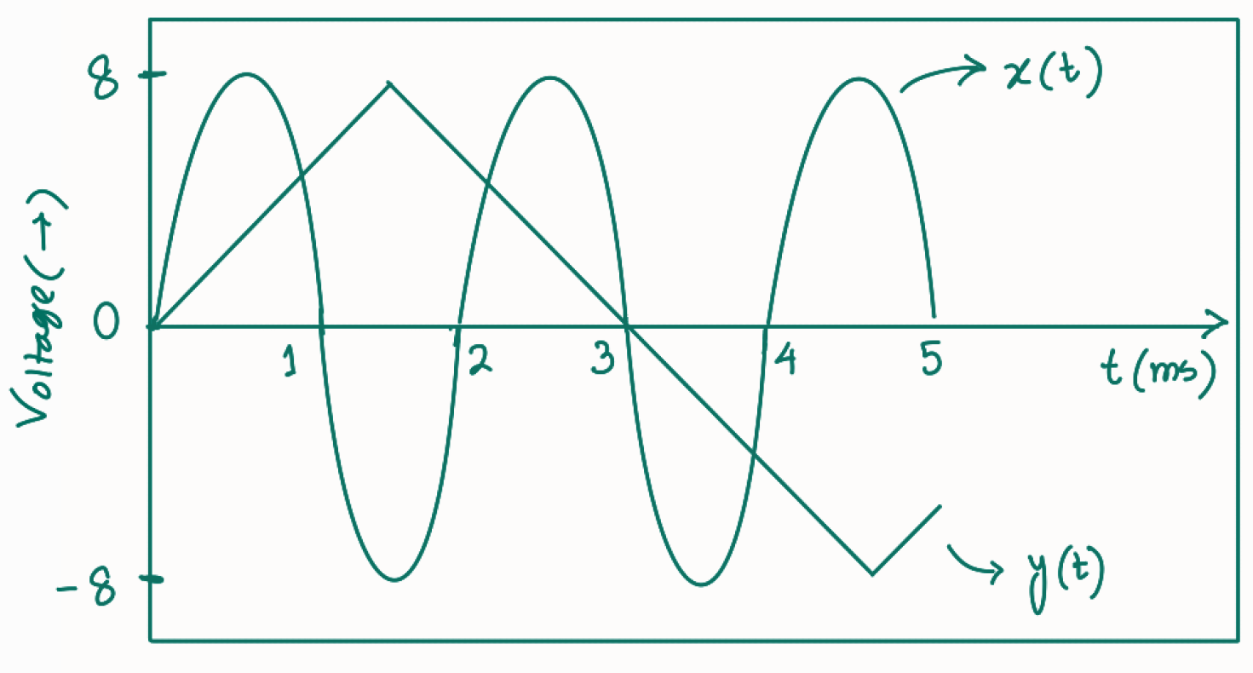

### 28. Miscellaneous

**Draw the VTC of both an inverting and a non-inverting amplifier. The following information are known:**

**(i) ${2R}_{1} = R_{F}$ (ii) ${V_{sat}}^{+} = +10V, {V_{sat}}^{-} = -10V$**

### 29. Miscellaneous

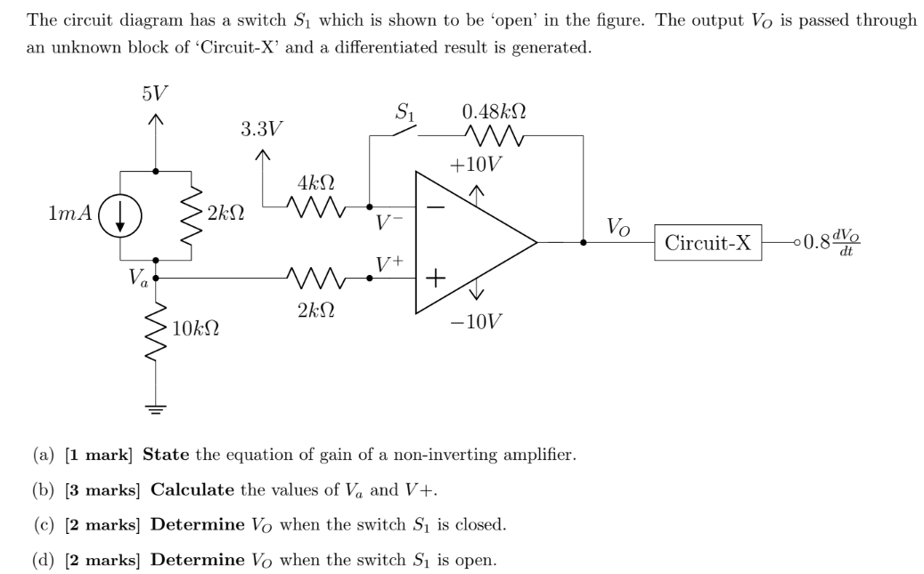

# **I-V**

### Identify which of these I-V curves are Linear and which are Nonlinear:

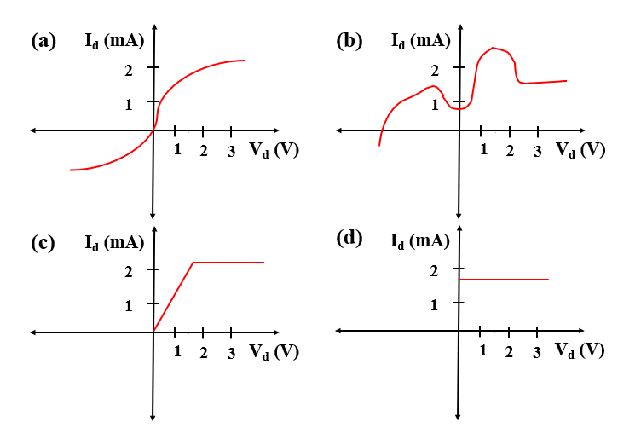

**Ans: Linear: (d)**

### Write down the slopes of these following regions in ascending order (you do not need to calculate the slopes)

1. 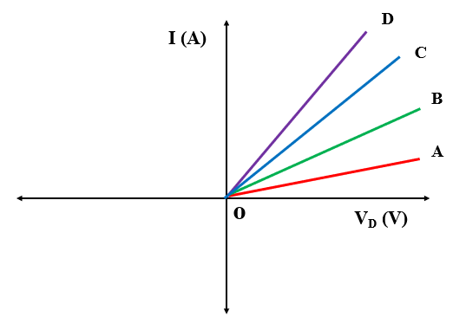(b) 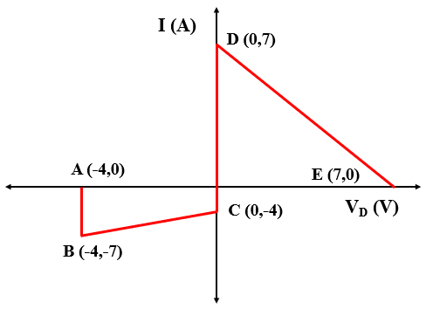

Ans: (a) |OA|<|OB|<|OC|<|OD|, (b) Slopes of AB and CD are equal(infinity). The DE slope is negative. However, the value of slope is higher than BC here. |BC|<|DE|<|AB|

### Find out the slope of the following curves



Answer: **Slope, |m|=**

|BC|= **=** =

|DE|= **=** =  **[Can you identify the issue in this curve? ]**

|AB|= **=** = **∞**

### Calculate and Show ‘C’ and ‘Io’ in the figures

**[Hint: use $-\frac{Vo}{R}=Io$ =c]**

### Draw the alternative circuit diagram, I-V curve and calculate the parameters with the following information:

i. Vo= 5V, m= 2 / $kΩ$

ii. Vo= 3.5 V, m= -2.5/ $kΩ$

iii. Vo= -5V, m= 5/ $kΩ$

**Solution:**

i. ||= i.e. $\frac{1}{2}$ $kΩ$, $c=-\frac{Vo}{R}$ = $-\frac{5}{0.5}mA=-2.5 mA$

ii. ||= i.e. $\frac{1}{2.5}$ $kΩ$, $c=-\frac{3.5}{0.4}mA=-8.75 mA$

iii. ||= i.e. $\frac{1}{5}$ $kΩ$, $c=-\frac{-5}{0.2}mA= 25 mA$

**Alternative Diagram:**

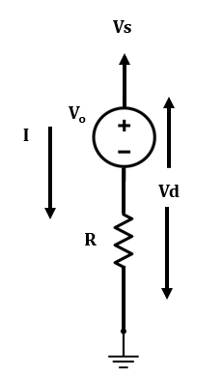

**I-V curve:**

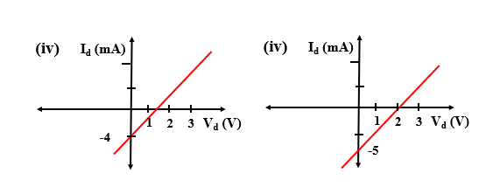

### Calculate and Show ‘C’ and ‘Vo’ in the figures

**[Hint: Use ]**

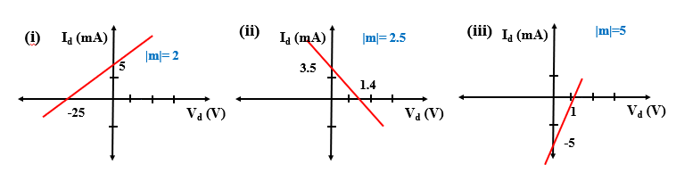

### Draw the alternative circuit diagram with the equivalent linear model, I-V curve and calculate the parameters with the following information:

i. Io= 5 mA, m= 2 $/kΩ$

ii. Io= 3.5 mA, m= -2.5 / $kΩ$

iii. Io= -5 mA, m= 5 / $kΩ$

**Solution:**

i. ||= i.e. $\frac{1}{2}$ $kΩ$, $c=Io$ = $5 mA$, $Vo=-IoR=-2.5 V$

ii. ||= i.e. $\frac{1}{2.5}$ $kΩ$, $c=Io=3.5 mA, Vo=-(-IoR)=1.4 V$; as m is negative

iii. ||= i.e. $\frac{1}{5}$ $kΩ$, $c=Io=-5 mA,Vo=-IoR=1 V$

**Alternative diagram:**

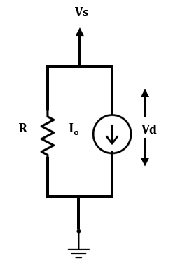

**I-V:** 

### From the I-V curve-

i. State the device model for each region,

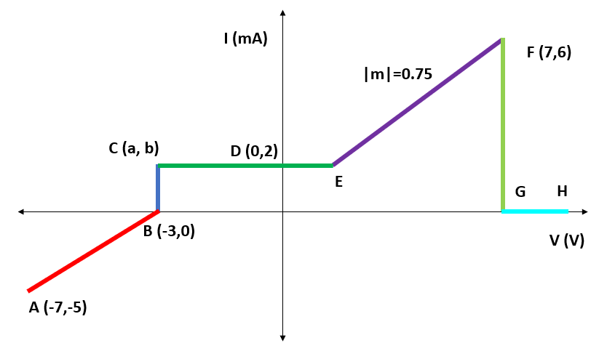

**Solution:**

**i.**

AB: Voltage source in series with a resistor/ Current source in parallel with a resistor

BC: Voltage source

CD: Current source

EF: Voltage source in series with a resistor/ Current source in parallel with a resistor

FG: Voltage source

### A Voltage Source, Vo= 10 V in series with a resistor of R= 3 $kΩ$.

i. Write down the equation representing this curve

ii. Determine the unknown parameters

iii. Label the I-V curve

**Solution:**

i. y= mx+c

Or, I= m. Vs $-\frac{Vo}{R}$

ii. Vo= 10 V, R=3

**|m|**

Y axis intersection: c= $-\frac{Vo}{R}$ = $-\frac{10V}{3kΩ}=-\frac{10}{3}$ mA

X axis intersection: $Vo$ = 10 V

iii.

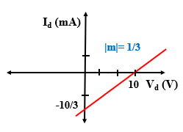

### A Voltage Source, Vo= -10 V in series with a resistor of R= 3 $kΩ$.

i. Write down the equation representing this curve

ii. Determine the unknown parameters

iii. Label the I-V curve

**Solution:**

i. y= mx+c

Or, I= m. Vs $-\frac{Vo}{R}$

ii. Vo= 10 V, R=3

**|m|**

Y axis intersection: c= $-\frac{Vo}{R}$ = $-\frac{-10V}{3kΩ}=\frac{10}{3}$ mA

X axis intersection: $Vo$ = -10 V

Iii.

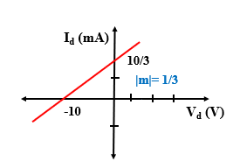

### A Current Source, Io= 5 mA in parallel with a resistor of R= 5 $kΩ$.

i. Write down the equation representing this curve

ii. Determine the unknown parameters

iii. Label the I-V curve

**Solution:**

i. y= mx+c

Or, $Is=\frac{Vs}{R}+Io$

ii. Vo= 10 V, R=5

**|m|**

Y axis intersection : c= $Io$ = 5 mA

X axis intersection: $IoR=-Vo$

Or, Vo= -5*5 V= -25V

iii.

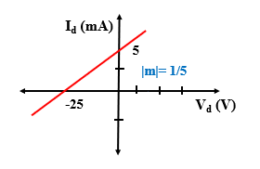

# 

# 

### You are provided with the following circuit elements:

• Two 1 kΩ resistors

• A 4 V voltage source

• A 2 V voltage source

Can you implement a circuit element X that has an IV characteristics, as seen in the right figure below, but by **ONLY USING THE ELEMENTS MENTIONED ABOVE**? The voltage polarity and current direction should be as shown in the left figure.

# 

# 

# **Diode Logic Gates**

### Assuming x, y, z are boolean variables, analyze the circuits below to find an expression of *“f”* in terms of x, y, and z.

#### i.

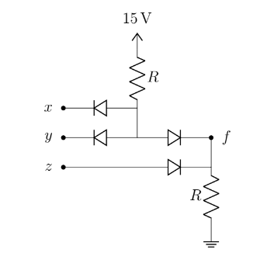

#### ii.

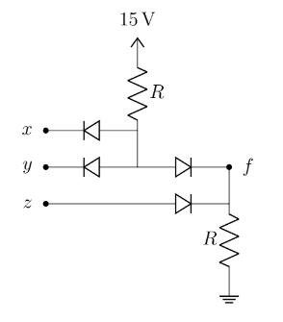

#### iii.

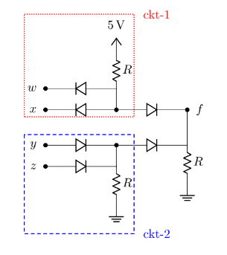

#### iv.

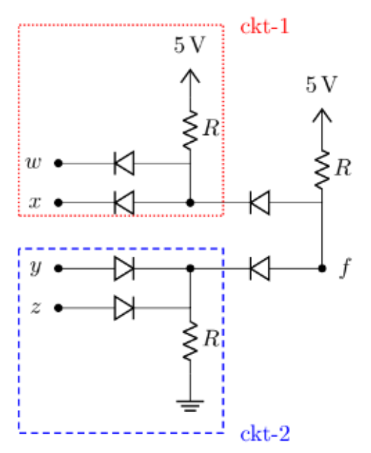

### Implement the following expressions using ideal diodes:

#### i. xy+ yz

#### ii. XOR

#### iii. XNOR

#### iv. (A+B)XY

### Design a 4 input AND gate using ideal diodes

### Design a 3 input OR gate using ideal diodes

### There will be 5 questions from 5 different topics in your exam and you will have to answer 4 out of these . You will need to fulfill the following conditions-

i. You **must** answer 3 questions from topic “A”, “B” and “C”

ii. You can answer one question from **either** “D” or “E”

Deduce the logic function using boolean variables A,B,C,D and E to implement your algorithm for choosing the questions.

### For this question, assume all the diodes are ideal.

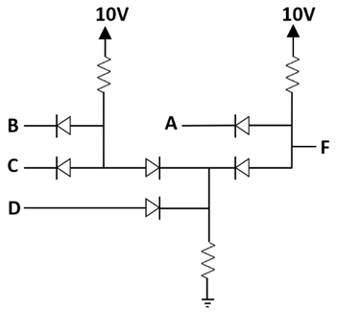

Figure 1

1. Assuming A, B, C, D are boolean variables, analyze the circuit of Figure 1 to find an expression of F in terms of A, B, C and D.
2. Analyze the circuit in Figure 1 to find the output voltage(s) F and complete the table in Figure 2, assuming A, B, C and D are voltage signals

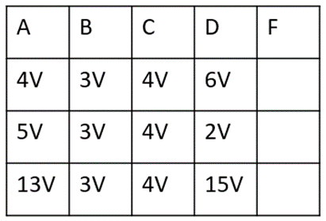

Figure 2

(c) Design a circuit using ideal diodes to implement the logic function

f = (x+y)z

### Maisha is designing a game where she needs to determine an algorithm for level upgrades. The quests in level-1 are expressed using Boolean variables A, B, C, D, and E. For upgrading from level-1 to level-2 she will need to fulfill the following conditions-

i. Quest “A” and “B” must be completed

ii. At Least one quest has to be completed from “C”, “D” and “E”

(a) **Deduce** the logic function, F, using Boolean variables A, B, C, D, and E to implement Maisha’s algorithm. [3]

(b) **Determine** the values of “F” in the following table using the logic function from (a). [2]

| A | B | C | D | E | F |
| --- | --- | --- | --- | --- | --- |
| 0 | 0 | 1 | 0 | 1 | ? |
| 0 | 1 | 1 | 1 | 0 | ? |
| 1 | 0 | 0 | 0 | 0 | ? |
| 1 | 1 | 1 | 0 | 0 | ? |

(c) **Draw** the circuit diagram implementing the logic function from (a). [3]

(d) **Discuss** whether you can design a NAND gate with Si diodes. [2]

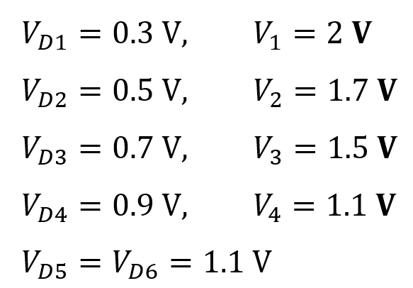

1. Find and $V_{6}$. [5]
2. Find $V_{O}$. [5]
3. **[BONUS – 5 Marks]:** Solve the circuit to get $V_{O}$ when $V_{1}=7 V, V_{2}=8 V$ and all other parameters remain the same.

# **Diode: Method of assumed states**

*For the following circuits (a) Analyze the following circuit to find the values of $I_{D1}$, $I_{D2}$, $V_{X}$, and $V_{Y}$. Here, use the Method of Assumed State using the CVD model of diode with $V_{D0}$ = 0.3 V. (b) Validate your assumptions about the states of the diodes.*

### 1.

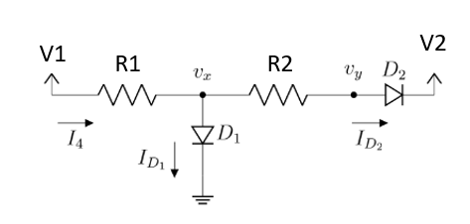

i. V1= 10 V, V2= -10 V, R1= 10 K, R2= 20K

ii. V1= -5 V, V2= 20 V, R1= 10 K, R2= 20K

### 2.

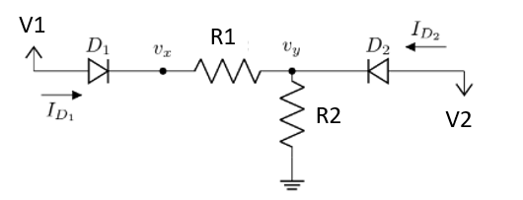

i. V1= 5 V, V2= -3.5 V, R1= 1 K, R2= 10K

ii. V1= 5 V, V2= -3.5 V, R1= 10 K, R2= 10K

### 3.

### 4.

# 

**Analyze** the circuit given above. **Calculate** the values of **I1, I2, I3**. You must **validate** your assumptions. Use the Constant-Voltage Drop model(CVD Model) with **VD0 = 0.8 V**.

### 5.

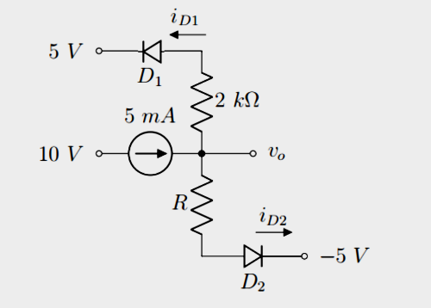

Find **Vo, iD1 and iD2** for R = 1 kΩ. Assume diode constant voltage drop model with Vdo = 0.7v . In each case, write down the states of the diodes (ON/OFF). You must verify your assumptions.

### 6.

# 

**Analyze** the following circuit. **Calculate** the values of VA, V0, ID1, and ID2. You must validate your assumptions. Use the Constant-Voltage Drop model with a cut in voltage of 0.6V [VD0 = 0.6 V]. *[Hints: You may start with calculating the voltage values first]*

* **Please find some other examples here**: [Week 4 (Method of Assumed State Examples).pdf](https://drive.google.com/file/d/1uMgvK4Vo4m_nfjzFVLr0OCmozDfUcihe/view?usp=share_link)

### 

### 7.

**The switches S1 and S2 are shown in open configuration below.**

**Assume, $V_{D0}= 0.7V$** (CVD model)

(i) Find the current passing through the $100k$ Ω resistor when only S1 is closed.

(ii) Find the current passing through the $100k$ Ω resistor when only S2 is closed.

# 

### 

### 

### 

### 

### 

# 

# **Rectifiers**

### 1.

The input of a full-wave rectifier is a cosine voltage with peak $V_{M}$ = 5 V and frequency 60 Hz, and output load resistance is R = 2 kΩ. Silicon diodes are used in this circuit for which the forward drop is $V_{D0}$ = 0.7 V.

(a) Briefly explain the purpose of a rectifier and describe its operation.

(b) Show the input and output waveforms.

(c) Calculate the DC value of the output voltage.

Now after connecting a capacitor in parallel with the load, the output becomes a ripple voltage **Vout = $V_{DC}$ ±0.2 V**

(d) Calculate the **peak-to-peak ripple voltage**, and from that, the value of the capacitor.

(e) Calculate the average of the output voltage after connecting the capacitor. Compare this with the DC value determined in ‘c’ and comment on the difference between these two.

### 2.

The input of a **Half-wave rectifie**r is a sine voltage with peak VM = 10 V and frequency 55 Hz, and output load resistance is R = 2.5 kΩ. Silicon diodes are used in this circuit for which the forward drop is $V_{D0}$ = 0.4 V.

(a) Calculate the DC value of the output voltage.

Now after connecting a capacitor in parallel with the load, the output becomes a ripple voltage **Vout = $V_{DC}$ ±0 V.**

(d) Calculate the **peak-to-peak ripple voltage**, and from that, the value of the capacitor.

(e) Calculate the average of the output voltage after connecting the capacitor. Compare this with the DC value determined in ‘c’ and comment on the difference between these two.

(f) Draw the **Voltage Transfer Characteristic (VTC) curve**

(g) What is the frequency of the Ripple voltage?

### 3.

The input of a full-wave rectifier is expressed by, Vs(t)= 7sin(400πt), and output load resistance is R = 5 kΩ. Silicon diodes are used in this circuit for which the forward drop is $V_{D0}$ = 0.3 V.

(a) Calculate the input and output wave frequency.

(b) Show the input and output waveforms.

(c) Calculate the DC value of the output voltage.

Now after connecting a capacitor, C= 100 µF in parallel with the load.

(d) Calculate the peak-to-peak ripple voltage,

(e) Calculate the average of the output voltage $V_{DC}$ after connecting the capacitor. Compare this with the DC value determined in ‘c’ and comment on the difference between these two.

(f) How can you provide better filtering for the output waves?

(g) What is the frequency of the Ripple voltage?

### 4.

The input of a **Half-wave rectifier** is a **Square** wave voltage with peak $V_{M}$ = 15 V and frequency 0.5 Hz, and output load resistance is R = 5 kΩ. Silicon diodes are used in this circuit for which the forward drop is $V_{D0}$ = 0.7 V.

i. Show the input and output waveforms.

ii. Draw the VTC curve

### 5.

The input of a **full-wave rectifier** is a **Square** wave voltage with peak $V_{M}$ = 15 V and frequency 0.5 Hz, and output load resistance is R = 5 kΩ. Silicon diodes are used in this circuit for which the forward drop is $V_{D0}$ = 0.7 V.

i. Show the input and output waveforms.

ii. Draw the VTC curve

### 6.

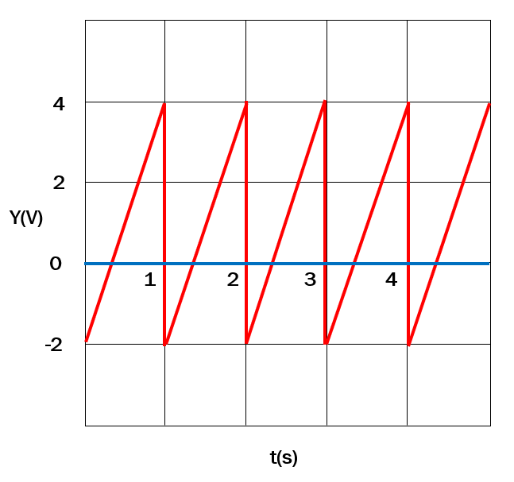

The input of a Half-wave rectifier is exhibited in the Figure above and output load resistance is R = 5 kΩ. Silicon diodes are used in this circuit for which the forward drop is $V_{D0}$ = 0.7 V.

i. Show the input and output waveforms.

ii. Draw the VTC curve

### 7.

A full-wave rectifier is designed to deliver a maximum current IL = 120 mA to the load. The rectifier produces an output with a ripple of 5% of the peak output voltage. An input line voltage of 120 V (peak), 50 Hz is available. A 10:1 step-down transformer is used to transform the supply voltage to 12 V (peak).

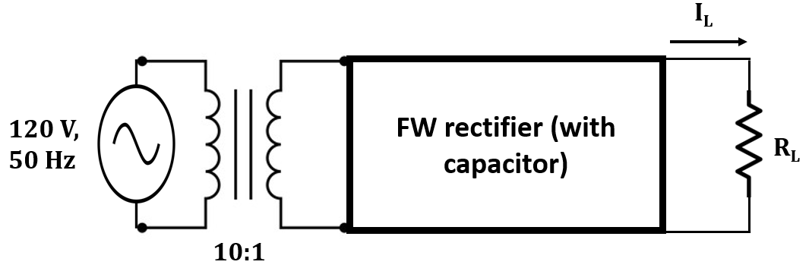

1. Draw the Voltage Transfer Characteristics of the full-wave rectifier. [2]
2. Calculate the peak output voltage. [1]
3. Determine the value of the Load Resistor to deliver a maximum load current of 120mA. [2]
4. Deduce the value of the Capacitor and the DC average value. [1]
5. Assume the transformer is removed and the rectifier is directly connected to the AC power supply line. Discuss the state of the diodes. [ Hint: use the Peak Input Value of the rectifier input] [3]

# 

# **Hybrid Problems [Diode, OP-AMP]**

### 1.

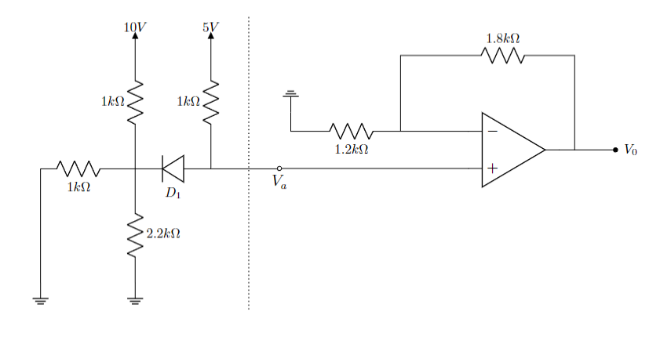

The saturation voltages of the Op-Amp are given as- $V_{sat}^{+}=+10V$ and $V_{sat}^{-}=-10V$. The forward voltage drop of the diode, $V_{D}$ is $0.7V$.

(a) **Determine** the operating mode diode, . Verify your assumption with necessary calculations.

(b) **Calculate** the voltage at - (i) node ‘Va’, (ii) non-inverting terminal of the Op-Amp, (iii) inverting terminal of the Op-Amp.

(c) Find out the output voltage, Vo of the Op-Amp.

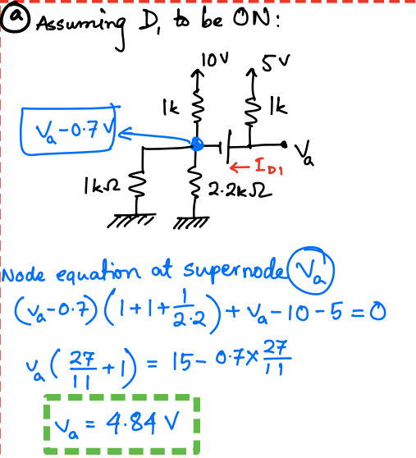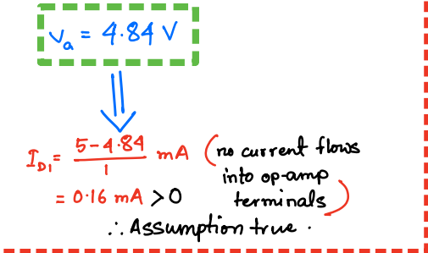

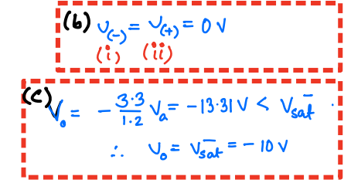



### 2.

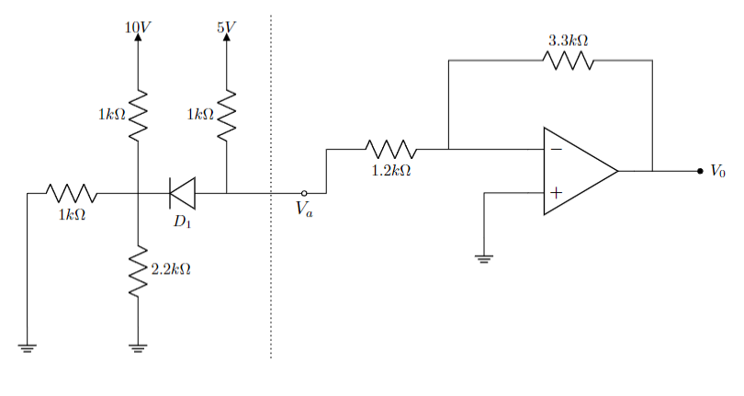

The saturation voltages of the Op-Amp are given as- $V_{sat}^{+}=+10V$ and $V_{sat}^{-}=-10V$. The forward voltage drop of the diode, $V_{D}$ is $0.7V$.

(a) **Determine** the operating mode diode, . Verify your assumption with necessary calculations.

(b) **Calculate** the voltage at - (i) node ‘Va’, (ii) non-inverting terminal of the Op-Amp, (iii) inverting terminal of the Op-Amp.

(c) Find out the output voltage, Vo of the Op-Amp.

### 3.

You are provided with the diagram below as a starting point for designing an AC to DC converter. Input voltage source is an sinusoidal voltage source ($V_{in}$), with 6V peak to peak voltage (i.e. 3 V amplitude) and the DC voltage is around 10 V (with ripple) at the output terminals ($v_{o}$).

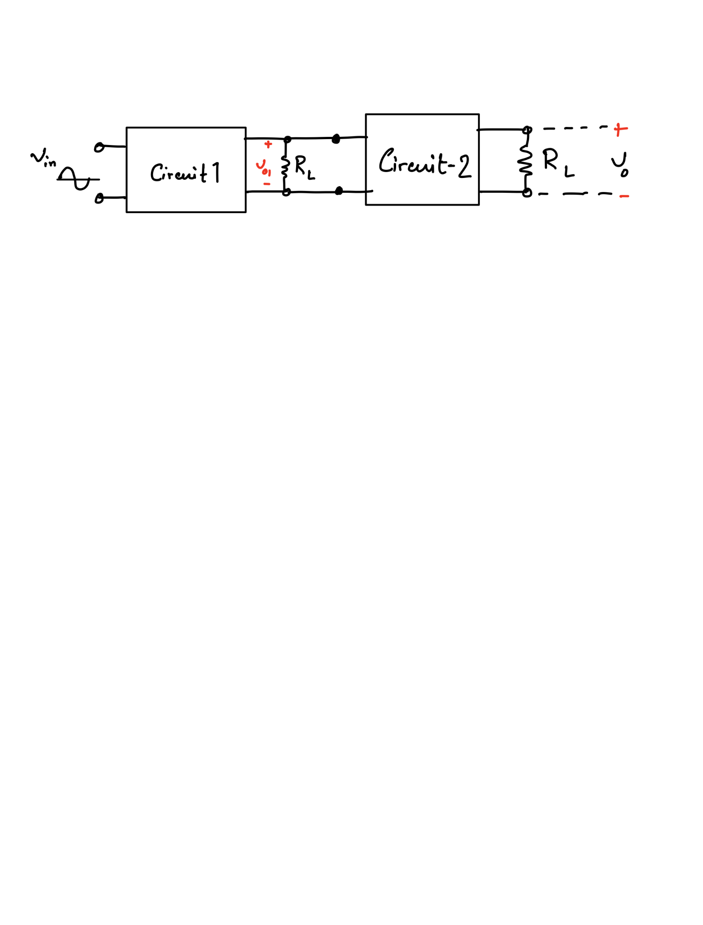  
So, in order to solve this problem, you are provided with a single diode (with $V_{D0}=0.7$ V), two resistors ( $R_{1}$ and $R_{2}$, excluding the load resistors $R_{L}$) and an UA741 op-amp.

1. Design **circuit-1** with the single diode and $R_{L}= 10 kΩ$ ($R_{L}$ is already provided in the diagram as output terminals of **circuit-1**) to get a rectified voltage and determine the DC value of the output voltage ($v_{o1}$) of the circuit. [1+2]
2. Determine the ripple voltage of $v_{o1}$. [Ripple voltage is defined as the difference between the maximum and minimum value of a DC voltage.] [2]
3. What should be the value of a capacitor used at the output end of **circuit-1** with $R_{L}$ to reduce the ripple voltage of $v_{o1}$ to 0. $1 V$. How should the capacitor be connected with $R_{L}$ in the diagram? [4+1]
4. Design an amplifier using an operational amplifier as **circuit-2** to increase the DC voltage level of the output voltage of the circuit designed in (c) to 10 V. Find the ripple voltage of the amplified voltage signal. [4+1]

### 4.

# 

### 5.

### 

# 

# **Rectifiers**

1. The input of a full-wave rectifier is a cosine voltage with peak $V_{M}$ = 5 V and frequency 60 Hz, and output load resistance is R = 2 kΩ. Silicon diodes are used in this circuit for which the forward drop is $V_{D0}$ = 0.7 V.

(a) Briefly explain the purpose of a rectifier and describe its operation. [1]

(b) Show the input and output waveforms. [2]

(c) Calculate the DC value of the output voltage. [1]

Now after connecting a capacitor in parallel with the load, the output becomes a ripple voltage **Vout = $V_{DC}$ ±0.2 V**

(d) Calculate the **peak-to-peak ripple voltage**, and from that, the value of the capacitor. [2]

(e) Calculate the average of the output voltage $V_{DC}$ after connecting the capacitor. Compare this with the DC value determined in ‘c’ and comment on the difference between these two. [2]

1. The input of a **Half-wave rectifie**r is a sine voltage with peak VM = 10 V and frequency 55 Hz, and output load resistance is R = 2.5 kΩ. Silicon diodes are used in this circuit for which the forward drop is $V_{D0}$ = 0.4 V.

(a) Calculate the DC value of the output voltage. [1]

Now after connecting a capacitor in parallel with the load, the output becomes a ripple voltage **Vout = $V_{DC}$ ±0.3 V.**

(b) Calculate the **peak-to-peak ripple voltage**, and from that, the value of the capacitor. [2]

(c) Draw the **Voltage Transfer Characteristic (VTC) curve [2]**

1. The input of a full-wave rectifier is expressed by, Vs(t)= 7sin(400πt), and output load resistance is R = 5 kΩ. Silicon diodes are used in this circuit for which the forward drop is $V_{D0}$ = 0.3 V.

(a) Calculate the input and output wave frequency. [2]

(b) Show the input and output waveforms.

Now after connecting a capacitor, C= 100 µF in parallel with the load.

(c) Calculate the peak-to-peak ripple voltage,

(d) How can you provide better filtering for the output waves?

(e) What is the frequency of the Ripple voltage?

1. The input of a **Half-wave rectifier** is a **Square** wave voltage with peak $V_{M}$ = 15 V and frequency 0.5 Hz, and output load resistance is R = 5 kΩ. Silicon diodes are used in this circuit for which the forward drop is $V_{D0}$ = 0.7 V.

i. Show the input and output waveforms. [4]

ii. Draw the VTC curve [2]

1. The input of a **full-wave rectifier** is a **Square** wave voltage with peak $V_{M}$ = 15 V and frequency 0.5 Hz, and output load resistance is R = 5 kΩ. Silicon diodes are used in this circuit for which the forward drop is $V_{D0}$ = 0.7 V.

i. Show the input and output waveforms. [4]

ii. Draw the VTC curve [2]

1. 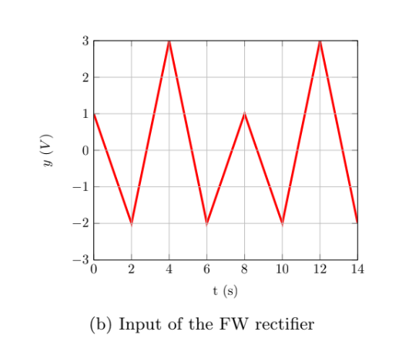

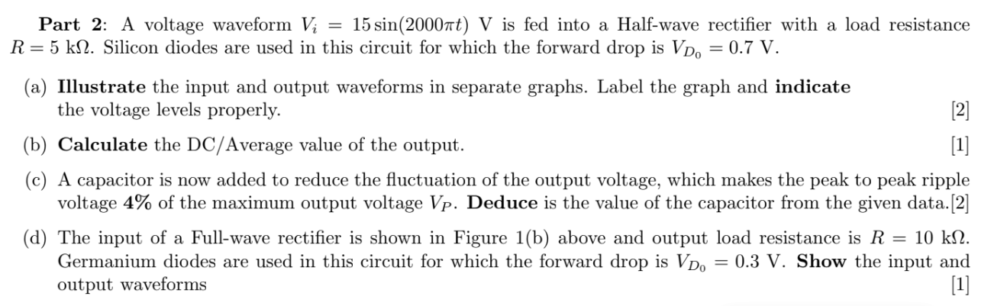



The input of a **Half-wave rectifier** is exhibited in the Figure above and output load resistance is R = 5 kΩ. Silicon diodes are used in this circuit for which the forward drop is $V_{D0}$ = 0.7 V.

i. Show the input and output waveforms. [3]

ii. Draw the VTC curve [2]

Iii. Calculate input and output frequency [3]



1. The input of a **full-wave rectifier** is exhibited in the Figure above and output load resistance is R = 5 kΩ. Silicon diodes are used in this circuit for which the forward drop is $V_{D0}$ = 0.7 V.

i. Show the input and output waveforms. [3]

ii. Draw the VTC curve [2]

Iii. Calculate input and output frequency [3]

1. A full-wave rectifier is designed to deliver a maximum current IL = 120 mA to the load. The rectifier produces an output with a ripple of 5% of the peak output voltage. An input line voltage of 120 V (peak), 50 Hz is available. A 10:1 step-down transformer is used to transform the supply voltage to 12 V (peak).



1. **Draw** the Voltage Transfer Characteristics of the full-wave rectifier. [2]
2. **Calculate** the peak output voltage. [1]
3. **Determine** the value of the Load Resistor to deliver a maximum load current of 120mA. [2]
4. **Deduce** the value of the Capacitor and the DC average value. [1]
5. Assume the transformer is removed and the rectifier is directly connected to the AC power supply line. **Discuss** the state of the diodes. [ Hint: use the Peak Input Value of the rectifier input] [3]

# **Zener Diode**

### Q1

The 6.8-V Zener diode in the circuit of **Figure** is specified to have the following parameters. The supply voltage $V^{+}$ is nominally **10 V** but can vary by **±1 V.**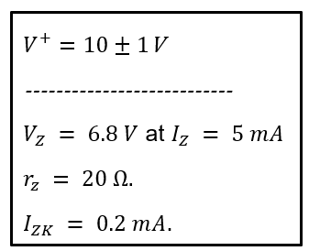

1. Find $V_{O}$ with no load and with $V^{+}$ at its nominal value
2. (For $R_{L}$**=0.5 kΩ**). Find the $I_{Z}$ In this scenario, calculate the Zener voltage $V_{O}$, load current $I_{L}$ and input current ***I***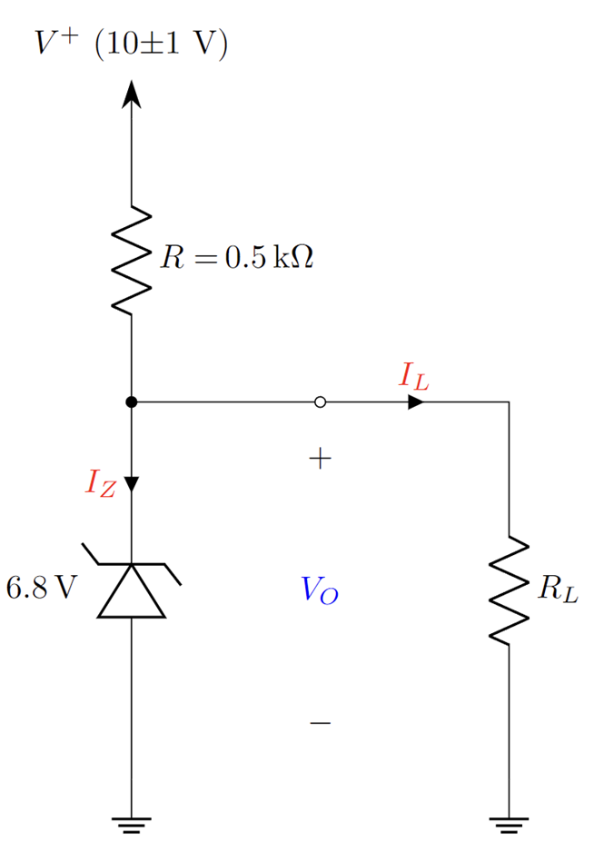
3. Find the $R_{L}$ that would give rise to worst-case scenario at worst case $V^{+}$. In this worst-case scenario, calculate the Zener voltage $V_{O}$ load current $I_{L}$ and input current $I$
4. (For $R_{L}$**=2 kΩ**). Find the $I_{Z}$ In this scenario, calculate the Zener voltage $V_{O}$, load current $I_{L}$ and input current ***I***
5. Design the circuit, i.e., find the minimum value of the input voltage $V^{+}$ such that, voltage regulation is maintained even in the worst-case scenario for $R_{L}$**=**2 kΩ. (Forget that $V^{+}$ is 10 V)
6. Determine whether the circuit will maintain regulation if $V^{+}$ is increased. If yes, argue if it should be increased or not.

### 

### Q2

The Zener diode in the circuit of Figure is specified to have the following parameters. The supply voltage 𝑽_𝒊𝒏 is nominally 𝟓 𝑽 but can vary by ±𝟏𝟎 %. Load current can vary from 𝟎 mA to 𝟓𝟎 mA.

1. Find minimum and maximum input Voltage, **V_in (min)** and **V_in (max)**, maximum and minimum load current **I_L (max)** and **I_L (min)**, minimum diode current **I_Z (min)**.
2. Find the **I_Z**, **V_in** and **I_L** at the worst-case scenario.
3. For the worst case what is **I_S** and **V_R**.
4. Find **R** for which diode maintains regulation at worst case scenario

### Q3

The Zener diode in the circuit of Figure is specified to have the following parameters.

1. Find minimum input voltage, 𝑽_𝒊𝒏 (min) for which the diode maintains regulation, when 𝑹_𝑳=𝟏𝟎 kΩ.
2. Find worst case 𝑹_𝑳 if the input voltage 𝑽_𝒊𝒏 is nominally 𝟓 𝑽 but can vary by ±𝟏𝟎 %

# **BJT**

## Q1

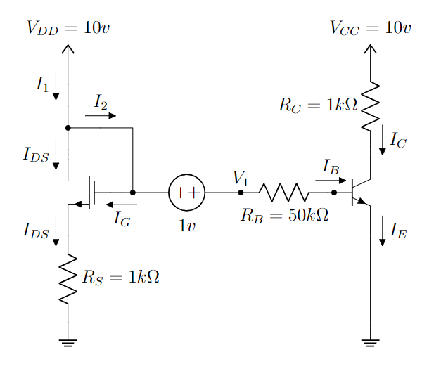

In the circuit above, the MOSFET and BJT have the following parameters,

**K = 4 mA/V2, VT = 0.9 v, 𝜷 = 100, VBE(active) = 0.7 v, VBE(sat) = 0.8 v**

1. **Find out the gate voltage of the MOSFET.**
2. **Calculate V1.**
3. **Find out the expression for VGS,VDS and VOV.**
4. **Find** the operating mode of the MOSFET using the expressions from ©. [Hint: You don’t need any assumption]
5. **Calculate** IDS and VDS using the given parameters.
6. Assume that the BJT is in the saturation mode. Now, **calculate** IB, IC, IE. You must **validate** the given assumption.

# 

# 

# 

# 

# 

## Q2

In the above circuit, Vbb = 5V, Vcc = 15V, R1 = 20kΩ(40kΩ), R2 = 80kΩ(60kΩ), R3 = 2kΩ and R4 = 1kΩ. Also, assume current gain, Ic/Ib = 100.

a) Draw the equivalent circuit of BJT during saturation and active modes. [2]

b) Solve the above circuit and calculate IB, IC, IE, VCE and VC using the method of assumed states. [Hint: try to find the Thevenin equivalent of the left hand side circuit from the B terminal and ground] [3]

c) If Vbb is changed from 5V to 5.1V, what happens to the outputs of the circuits? Calculate IB, IC, IE, VCE and VC again. Now for a 0.1V increase in input Vbb, what is the change of Ic? Use ΔIC = IC,new­ - IC,old. [3+1]

d) Explain any use case of the differences in voltage increase between input and output. What could the use case be to such a phenomenon? [1]

# **MOSFET**

## Q1.

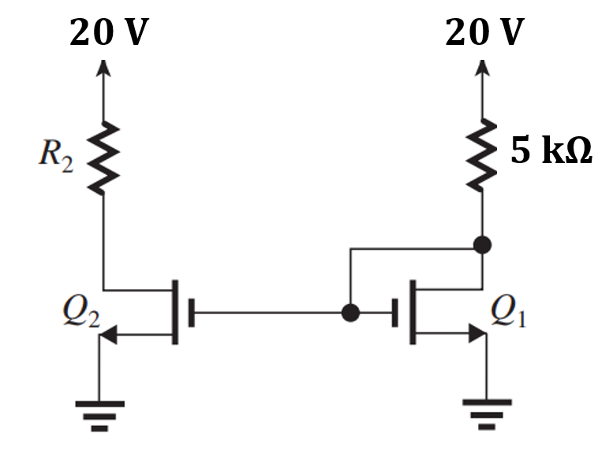

In the circuit above, the MOSFETs have the following parameters, k’n=2 mA/V2, W/L= 2.5, VT=0.5 V.

(a) **Find out** the operating mode of Q1 [Hint: For Triode mode Vds<Vov and for Saturation Vds>= Vov]

(b) **Determine** the value of R2 that results in Q2 operating at the edge of the saturation region.

(c ) **Calculate the on-state resistance,** Ron for Q2. Assume, gate voltage of Q2 is 20 V.

(d) An inverter is designed using Q2 and a 10K resistor. **Draw** the VTC graph for the inverter.

## Q2.

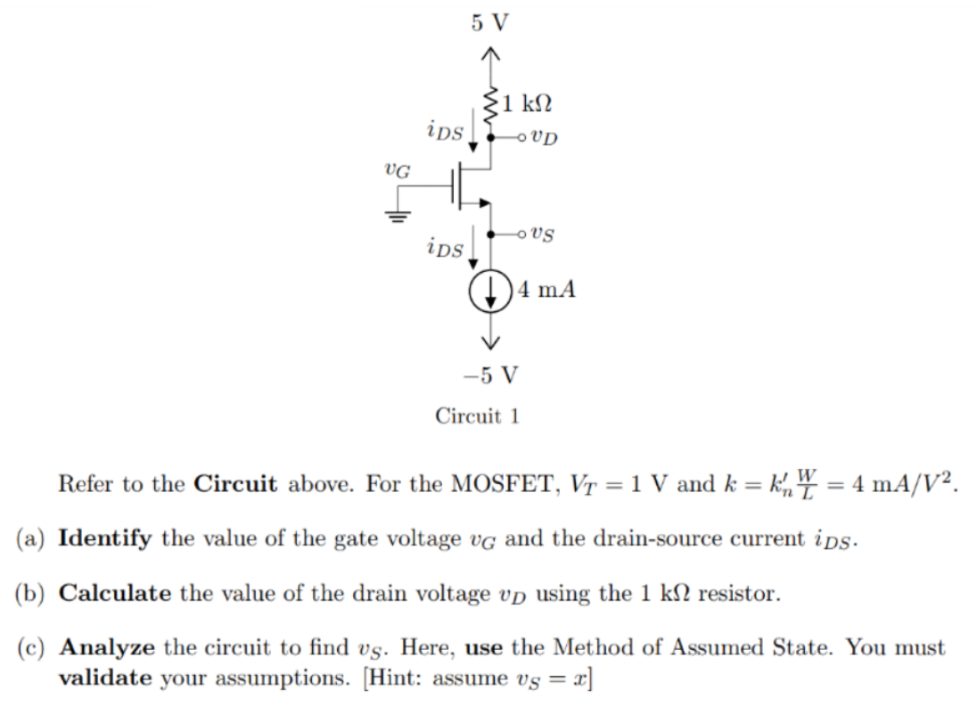

## Q3

For the following circuit, find **f** in terms of boolean input **A, B, C, D**.

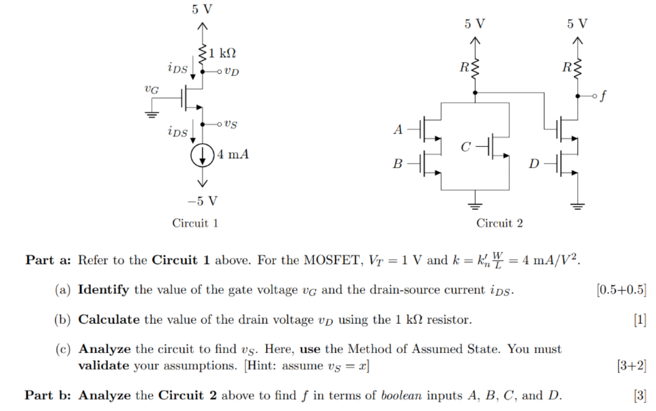

## Q4

Use MOSFET to implement the Boolean Logic function, **F = $\underline{A\underline{B}+C}$**

## Q5

I. Draw the VTC of a NOR gate using MOSFET S-model. ii. Draw the VTC of a NOR gate using MOSFET SR-model. Let, Ron= 100 ohms, RL= 10 Kohms, Vss=5 V.

## Q6

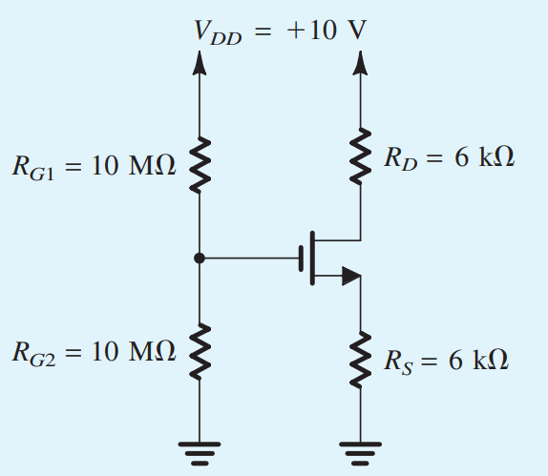

Analyze the circuit to find iD and vD using Method of Assumed State. You must validate your assumptions.

Here, VT = 1v, k = 5 mA/v2

## **Q7**

## Q8

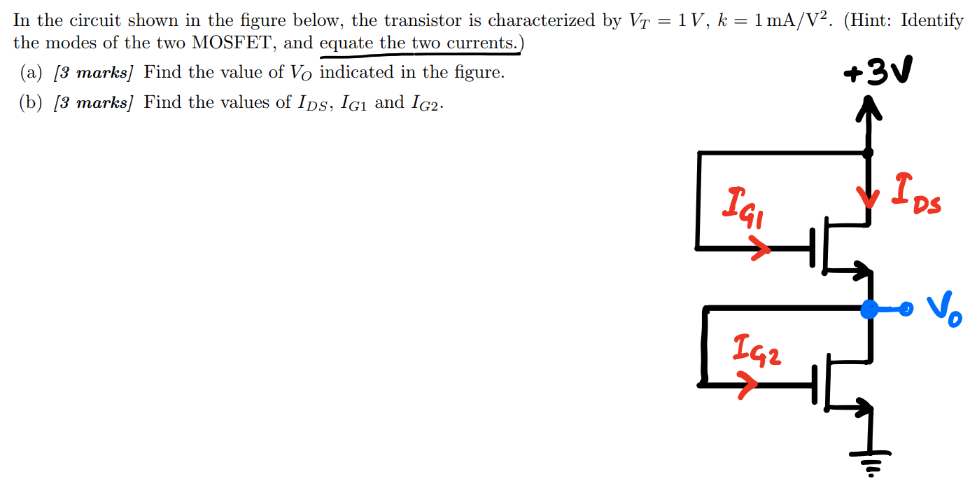

## Q9 *(1st ckt has too many equations and variables to solve by hand, 2nd ckt can be solved, each mosfet ckt should give you 2 equations in 2 variables with appropriate substitutions, try to solve 2nd ckt to get some practice solving with SR models )*

***Another hint: SR model is simply the approximate of the MOSFET equation, Id = k(Vov*Vds - Vds^2/2) with Vds^2 negligible, thus giving us, Id = k*Vov*Vds. This should be clear since voltage by current is resistance, and here, Vds / Id = 1 / (k * Vov) = Ron as we learned. So, SR model is a simpler model of MOSFET equation in triode region!***

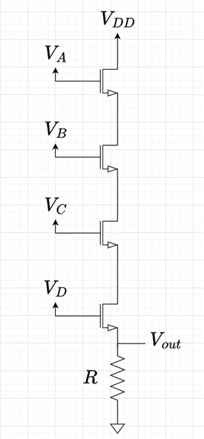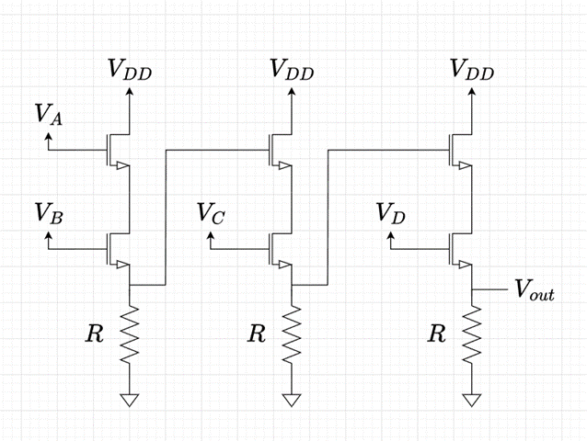

Circuit-1 Circuit-2

The above 2 circuits are implemented for logic gates using n-MOSFETs. All input voltages, VDD, VA, VB, VC and VD are 5V. Given, each n-MOSFET has the following parameters for its SR model: V¬T = 1V, k = 2.5 x 10-4 A/V2 (be wary of units!) and Ron = 1/(kVOV Ω). Also given, VOV = VGS - VT (For this problem, approximate VGS to be equal to VG)

a) Write down the SR model of an n-MOSFET. [1]

b) Find the logic expressions for circuit-1 and circuit-2. [2]

c) Using the SR-model of MOSFET, solve circuit-1 and circuit-2 and find the output voltage, Vout when all inputs, VA, VB, VC and VD are high(+5V). Given, R = 800 Ω. Do the two circuits give the correct output as per their logic expressions? [3]

d) If the outputs of the two circuits are used as gate voltage to a similar n-MOSFET, will it work as intended? That is, will a logical high in output be seen as logical high in the input of any n-MOSFET? If not, what can you do to remedy this. Explain with necessary calculations. [4]

## **Q10**

**MOSFET Design**

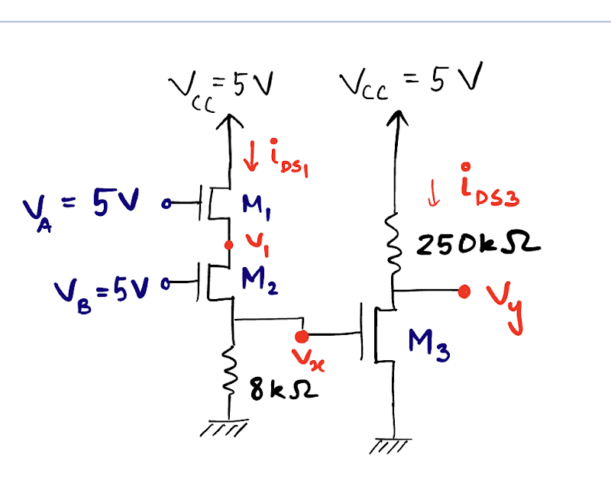

For the following circuit with MOSFETs, assume that =1 V, A/and the aspect ratio W/L is 1 for all the MOSFETS.

1. If the gate voltage to M3 MOSFET,  V, and MOSFET M2 is in triode mode, find the voltage . *[3]*
2. Find . *[2]*
3. If W/L=2, then  = 2.1454 V. Find  for this case. [2]
4. Can you explain, whether there will be any changes in the output voltage at  for W/L = 2 from that in (‘b)’. Also, comment on whether a larger or smaller value of W/L ratio is preferred in this case. [2+1]



For the following circuit with MOSFETs, assume that =1 V, A/and the aspect ratio W/L is 1 for all the MOSFETS.

1. If the gate voltage to M3 MOSFET,  V, and MOSFET M2 is in triode mode, find the voltage . Verify the modes for both M1 and M2 *[3]*
2. Find . *[2]*
3. If W/L=4, then  = 2.04 V. Find  for this case. [2]
4. Can you explain, whether there will be any changes in the output voltage at  for W/L = 4 from that in ‘b)’. Also, comment on whether a larger or smaller value of W/L ratio is preferred in this case. [2+1]

## Q11

a)For figure-2, place the switches as nmos devices and write the output logic function Y in terms of A,B,C,D assuming nmos switch model. [ 2]

b)From figure-2, assuming SR model for nmos find the output voltage when only A and D switches are ON( Assume Ron= 0.1 KΩ) [3]

c)For figure-1, k=2 mA/V2  , VT =1 V [3+2]

i)Find the gate voltage so that the mosfet is in saturation mode.

ii) Then find the minimum supply voltage Vss to operate the device in this

condition. [Hints , Vov=VDS]

d)**Bonus** - from figure-2 is it possible to drive a not gate cascaded to Vout ?

[VT =0.5V, Vout(low)=Vout of question(b)] [2]

## Q12 (MOSFET+Diode)

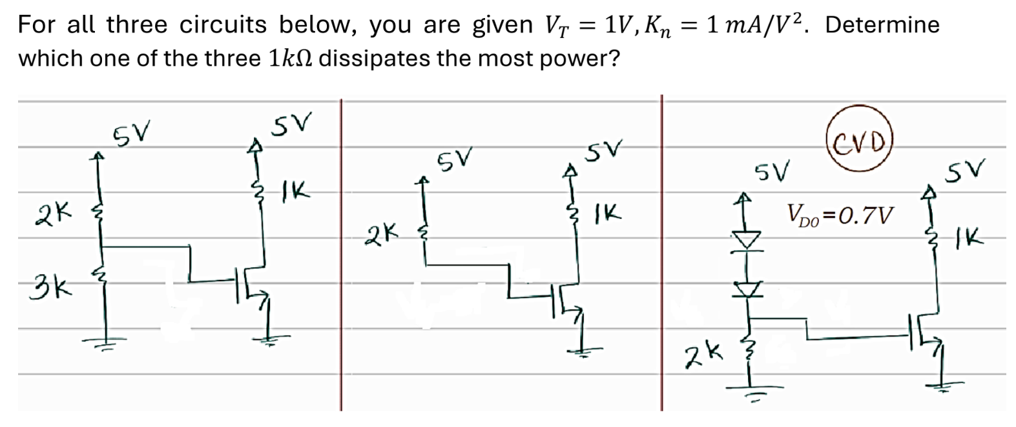

## Q13

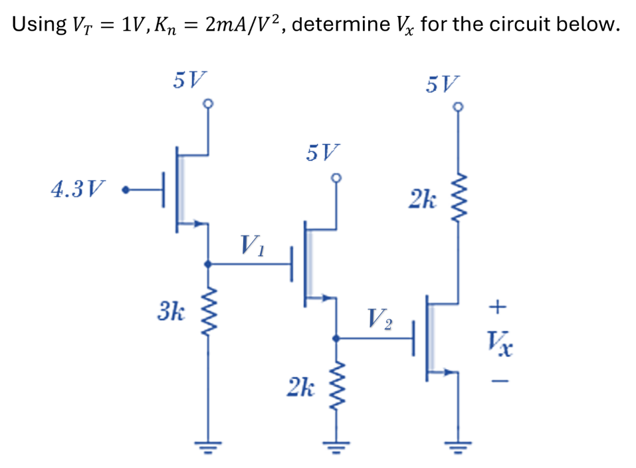

## Q14 (MOSFET+Diode)

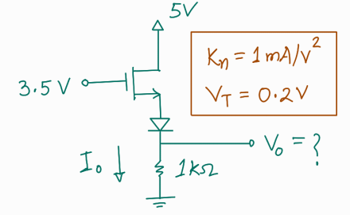

## Q15

## Q16

## 

You are given (i) E=2, or, (ii) E=5. Determine the operation modes of the *M1* and *M2* MOSFETs. Also, find the power dissipated in the 2kΩ resistor.

## 

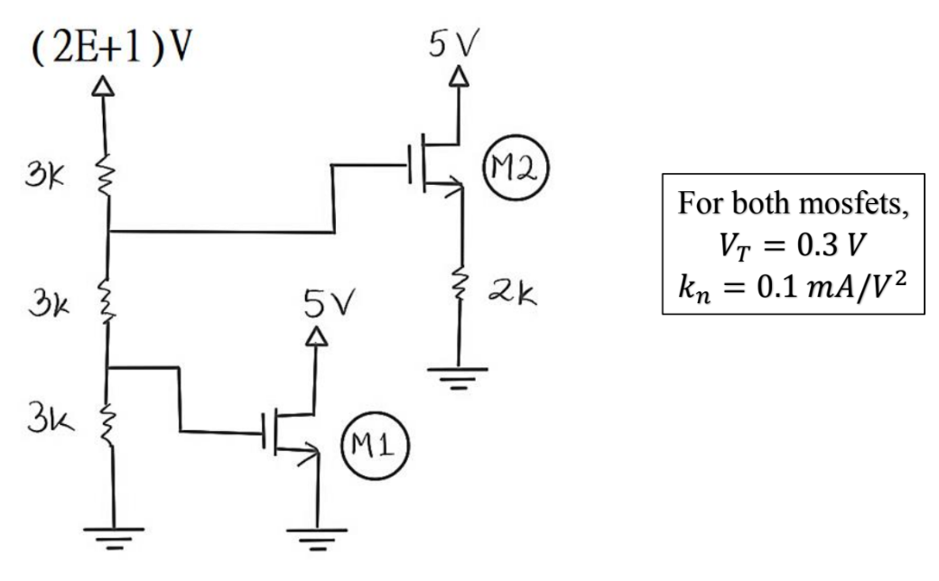

# 

# 

# 

# 

# 

# 

# 

# Hybrid

## 

## Q1 [MOSFET, Zener]

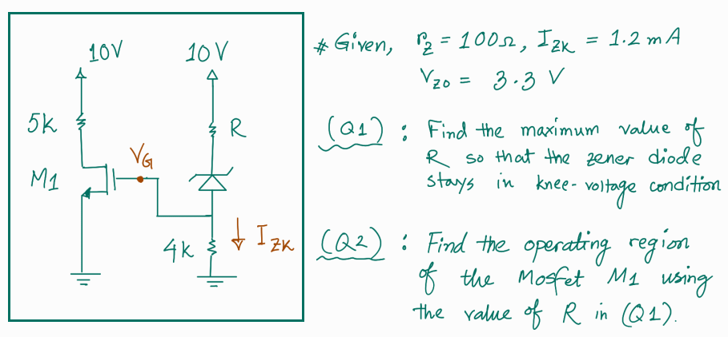

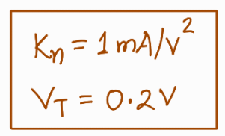

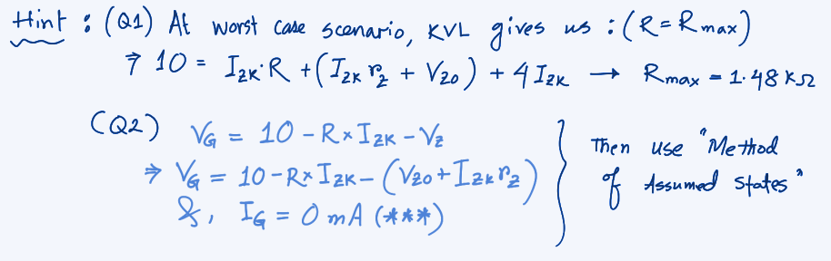

# 

# 

# 

# 

# 

## Q2 [MOSFET,BJT]

## 



 